Joshua Nguyen

Programming Fundamentals III COSC 2336

February 27 2017

Project 1 (200 Points)

**Part I: (100 Points)**

Describe in your own words and in detail with example what are the following 7 functions are in Analysis Tools:

The Constant Function:

A **Constant Function** is a function that when a keyword, *const* is used in a function’s declaration. It is however cannot be altered by the program while coding in C++. While a function is declared as a constant or in keyword *const,* it can be called on any data type of an object. Non-constant functions act only if called by non-constant objects. It provides a linear, yet basic element of the array. For example, we can have the following program here to return as a constant.

Example:

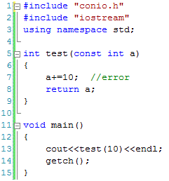

The Logarithm Function:

When we have a **natural logarithm function** in C++, we usually use a keyword *log* calculated the value of the logarithm. In function, we use base-e logarithm as a natural log for the computing algorithm. To note, if a value of x is negative, it will cause a domain error and if x is zero, it will cause a pole error from having an invalid output.

Example:

#include <stdio.h>

#include <math.h>

int main ()

{

double param, result;

param = 5.5;

result = log (param);

printf ("log(%f) = %f\n", param, result );

return 0;

}

The N-Log-N Function:

The **N-Log N Function** usually associated itself with longest increasing subsequence (LIS) in the array to implement a logarithm value in the algorithm. Longest increasing subsequence is the given sequence problem that the function elements are in sorted order from the lowest to highest value when we analysis an algorithm. The function In these examples, we trying to find the length of the longest subsequence of the given problem of all the sorted elements in the subsequence.

Example:

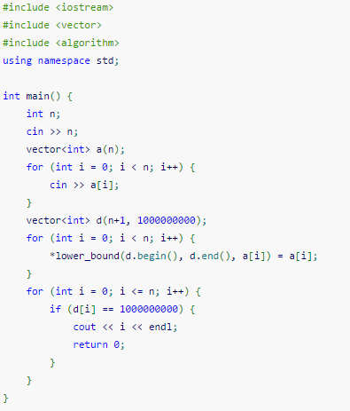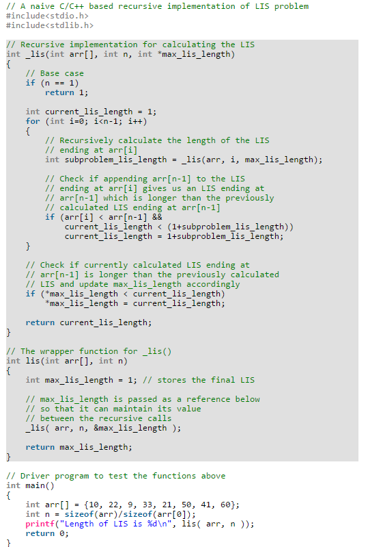

The Quadratic Function:

For a quadratic equation, we using associated ourselves with the typical formula ax2+bx+c = 0 and -b + sqrt(b^2 -4ac)/2a to get our roots when y is zero. Function like f(n) = n^2 are used in C++ like n*n = n^2 in many operations. In programming, we use keyword *sqrt(determinant)* to get our roots when determinant is greater, equal or less than zero. In this example code, we enter the coefficient of determinant to find the roots from if statements greater, lesser or equal to zero.

Example:

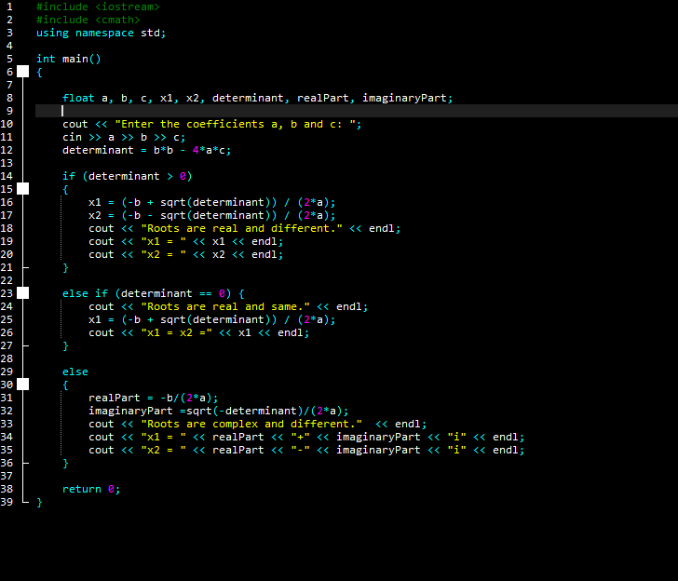

The Cubic Function and Other Polynomials:

The cubic functions appear less often in the algorithm compared to linear and quadratic functions. When we have n doubles, our running time increases fondly. We use f(n) = n^3 as usual in a cubic problem. For example, we can used n by n matrix multiplication to create a larger class of functions.

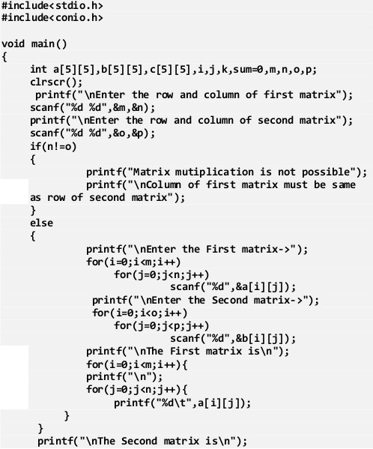

The Exponential Function:

When we have an exponential function in a programming activity, the most common base for the function is b = 2. Usually, this is not the case for a typical math problem you would use as a base in everyday moments. The function f(n) = b ^ n is used to perform an operation and double the number of operations within each iteration when we start our loop. However, it is not practical function for everyday programmer to use. For example, we can use a tower algorithm to implement the function efficiently.

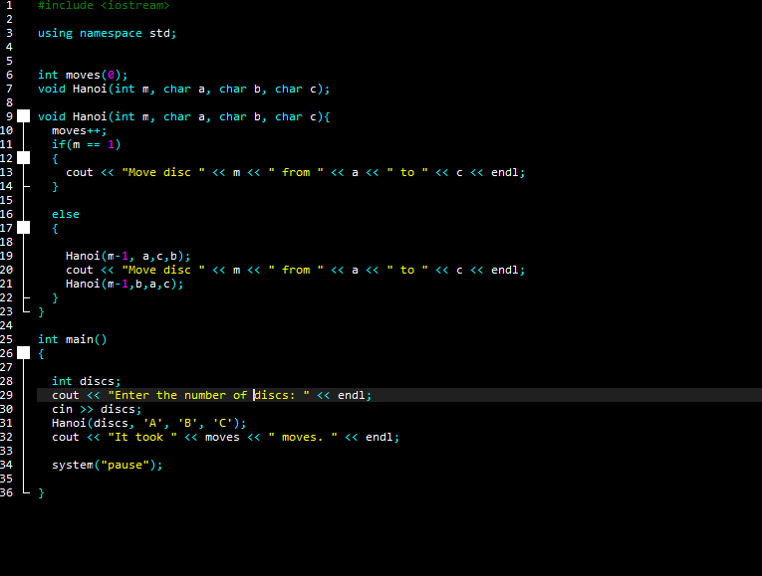 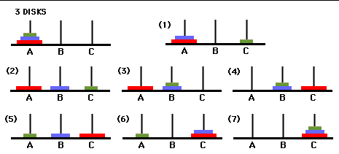

**Part II: (75 Points)**

Describe in your own words and in detail with example what are the following two:

Asymptotic Notation: asymptotic notation are languages that help us to analyze and understand a typical C++ algorithm’s time by looking for its increasing input size. They identify the behavior of a algorithm by using typical function like logarithmic, liner, quadratic, polynomial, and exponential function. It is often used in O-notation for an upper bound examples like f(n) = O(g(n)) if any constant and n is greater than 0. However, it is used in worst case analysis. Here is an example of that scenario.

**2N^2 = O(n^3) when c =1 and n = 2**

Asymptotic Analysis: Asymptotic analysis is used as a method to describing the limiting behavior of the function. In mathematics, it is often used in analysis on a long run scenario of random variables in a problem. In computer science, it is however applied to data in which have a very big value to performance of an algorithm. For example, we used to analyze a running time of a input size of a program to estimate the time or space of the function given in a program. In this example, we use T(n) as time function as n gets large as possible.

***T*(*n*)*= c*n*2*+k***

**T '(n) = c'*n*log2(n) + k'**

**Part III: (25 Points)**

What would be the output of the following sequence of queue operations:

enqueue(5), enqueue(3),dequeue(),enqueue(2),enqueue(8),dequeue(),

dequeue(),enqueue(9),enqueue(1),dequeue(),enqueue(7),enqueue(6),

dequeue(),dequeue(),enqueue(4),dequeue(),dequeue(),

**Output:**

Enqueue (5), Enqueue (3 ), Dequeue ( ), Enqueue(2), Enqueue(8 ), Dequeue ( ), Dequeue ( ),

   5                    5,3                3                     3,2                 3,2,8         2,8                    8

Enqueue(9 ), Enqueue( 1), Dequeue ( ), Enqueue (7), Enqueue (6), Dequeue ( ), Dequeue ( ),

     8,9              8,9,1                9,1                9,1,7           9,1,7,6            1,7,6                   7,6

Enqueue(4 ), Dequeue ( ), Dequeue ( ),

     7,6,4           6,4                     4